

UNIVERSITY OF INFORMATION TECHNOLOGY – VNU-HCM

**FACULTY OF COMPUTER NETWORKS AND COMMUNICATIONS**

1. Networking Concepts and Static Routing

NETWORKING TECHNOLOGIES– v1.2025

**PHỤC VỤ MỤC ĐÍCH GIÁO DỤC**

FOR EDUCATIONAL PURPOSE ONLY

Student name: Trần Ngọc Bá Duy

Student ID: 24560039

# OVERVIEW

## Learning objective

The learning objective of this lab is to get familiar with network devices, how they work together, and the concepts of routing. Moreover, students may practice on physical networking devices or simulation networking applications such as Cisco Packet Tracer. This lab will cover the following topics:

* + 1. Introduction to popular networking devices
    2. How to configure networking devices
    3. The routing concepts and static routing

## Practice Environment

### Netacad account

Students need an account at https:[//w](http://www.netacad.com/)ww[.netacad.com/](http://www.netacad.com/) to download the necessary resources and use applications released by Cisco. It’s free to create a new account here.

### Cisco Packet Tracer

**2**

Packet Tracer is a simulation, visualization, and collaboration tool for learning networking. It allows students to construct their own model or virtual networks, obtain access to important graphical representations of those networks, animate those networks by adding their data packets, and finally annotate and save their creations.

You need to download the newest version or the recent stable version of Packet Tracer Tool at https://skillsforall.com/resources/lab-downloads. Furthermore, you may enroll in the *“Getting Started with Cisco Packet Tracer course”* at https://skillsforall.com/topics/cisco-packet-tracer to familiarize yourself with the usage of the Packet Tracer Tool under the instruction of Cisco Academy.

# LAB TASKS

**3**

## Basic router configuration and static routing

The network topology is shown in the Figure 1 below. We use 3 routers, 2 switches, and 3 PCs (or laptops). You need to choose the necessary devices and cables, then set up the network as shown in the topology.

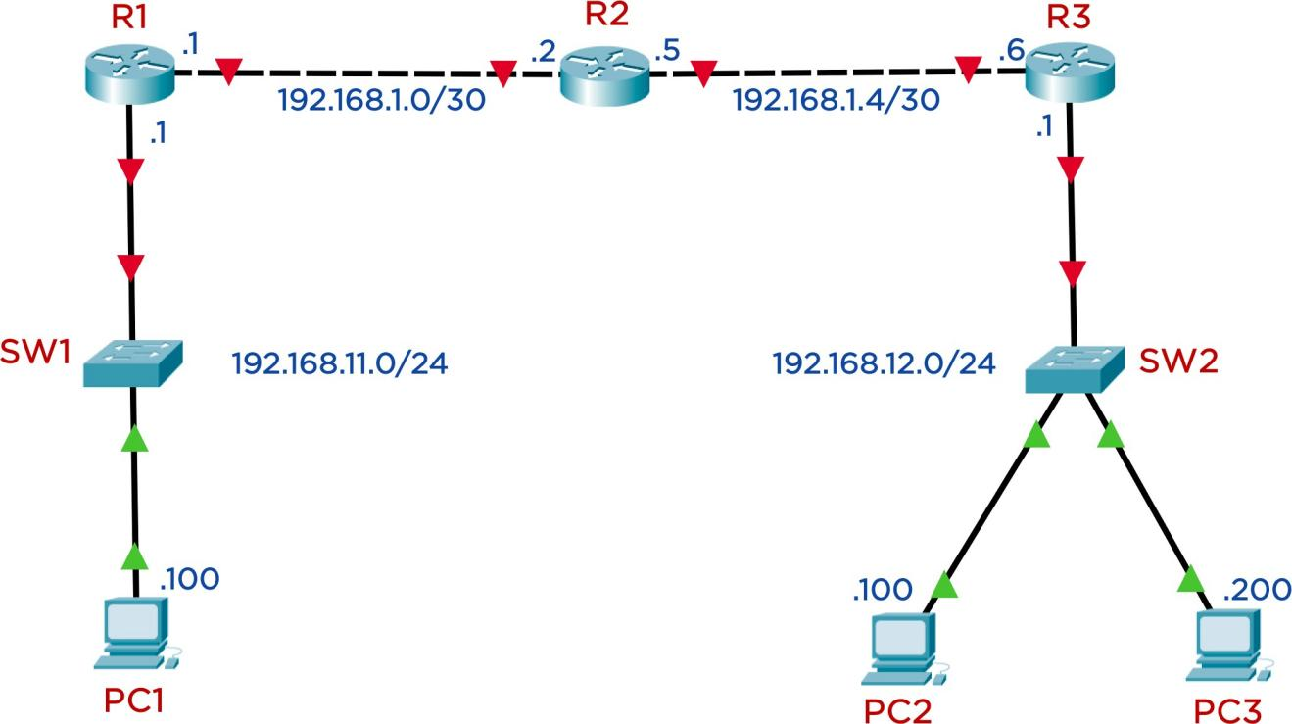

*Figure 1: Network topology for Task 1 Table 1: The IP Address for devices on task 1*

|  |  |  |  |  |
| --- | --- | --- | --- | --- |
| **Device** | **Interface** | **IPv4 Address** | **Subnet Mask** | **Default Gateway** |
| **R1** | G0/0/0 | 192.168.11.1 | 255.255.255.0 | None |
| G0/0/1 | 192.168.1.1 | 255.255.255.252 | None |
| **R2** | G0/0/0 | 192.168.1.2 | 255.255.255.252 | None |
| G0/0/1 | 192.168.1.5 | 255.255.255.252 | None |
| **R3** | G0/0/0 | 192.168.12.1 | 255.255.255.0 | None |
| G0/0/1 | 192.168.1.6 | 255.255.255.252 | None |
| **PC1** | NIC | 192.168.11.100 | 255.255.255.0 | 192.168.11.1 |
| **PC2** | NIC | 192.168.12.100 | 255.255.255.0 | 192.168.12.1 |
| **PC3** | NIC | 192.168.12.200 | 255.255.255.0 | 192.168.12.1 |

**4**

**Requirements:**

1. Identify the network devices and network cables to be used and connect according to the topology.
2. Set the corresponding hostname to all devices.
3. Set Banner Motd as ***“Warning: Authorized Access Only to <StudentID>”***

(<StudentId> is your student ID) to all routes.

1. On each router, set the password ***uitcisco*** for the privileged mode, the user EXEC mode.

You should encrypt password to enhance the security.

1. Assign IP address to all necessary interfaces of routers and PCs.
2. Allow users to configure via telnet all routers remotely.
3. ***(Advanced)*** Apply the static routing technique to suitable devices so that all PCs can communicate with each other.

*You should frequently copy the Running-configuration to the Startup-configuration to avoid losing configuration when the device unexpectedly reboots.*

## Subnetting and static routing

**5**

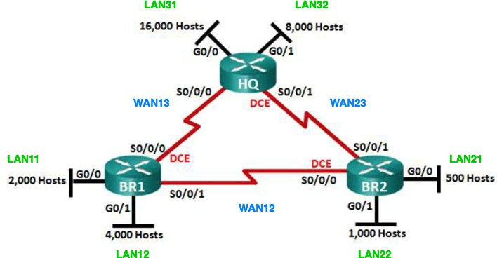

*Figure 2: Network topology for task 3*

A company needs to set up the network infrastructure as shown in the Figure 2. You need to subneting the network **172.16.0.0/16** into suitable subnets using VLSM1 method.

### Requirements:

* + 1. Subnetting the given network and filling out the result to the Table 2. You need to briefly explain how to get that result.
    2. Basic configure on router devices:
       - Set the hostname to all devices.
       - Set the password ***uitcisco*** on all routers for privileged EXEC, user EXEC, and Telnet remote access.
       - Set the Banner motd for all routers: *“Warning: Authorized Access Only on Router X”*
    3. Assign the IP address to the routers' interfaces. The subnet's first usable IP address is reserved for the router's interface in each LAN zone. You need to fill out this information for **Table *3***.
    4. All routers need to configure static routing. So that all devices can communicate with each other.
    5. Configure any redundancy routes to ensure the Router BR1 and BR2 can communicate with each other even if the direct link (link WAN12) fails.

*Tips: You can use the* ***floating static route*** *to achieve this goal.*

***Note:***

* + - * *To avoid losing your configuration, you should copy Running-configuration to Startup-configuration before shutdown or close network topology on Packet Tracer Tool.*
      * *Remember to include the topology file (.PKT) in your submission.*

1 Variable Length Subnet Mask method

**Table 2: Subnets information**

**6**

|  |  |  |  |
| --- | --- | --- | --- |
| **Subnet** | **Network Addres (CIDR)** | **First IP Address** | **Broadcast Address** |
| LAN11 | 172.16.112.0 | 172.16.112.1 | 172.16.119.255 |
| LAN12 | 172.16.96.0 | 172.16.96.1 | 172.16.111.255 |
| LAN21 | 172.16.124.0 | 172.16.124.1 | 172.16.125.255 |
| LAN22 | 172.16.120.0 | 172.16.120.1 | 172.16.123.255 |
| LAN31 | 172.16.0.0 | 172.16.0.1 | 172.16.63.255 |
| LAN32 | 172.16.64.0 | 172.16.64.1 | 172.16.95.255 |
| WAN12 | 172.16.126.0 | 172.16.126.1 | 172.16.126.3 |
| WAN13 | 172.16.126.4 | 172.16.126.5 | 172.16.126.7 |
| WAN23 | 172.16.126.8 | 172.16.126.9 | 172.16.126.11 |

**Table 3: Interfaces’ address**

|  |  |  |  |  |
| --- | --- | --- | --- | --- |
| **Device** | **Interface** | **IP Address** | **Subnet Mask** | **Default Gateway** |
| **HQ** | S0/0/0 | 172.16.126.6 | 255.255.255.252 |  |
| S0/0/1 | 172.16.126.9 | 255.255.255.252 |  |
| G0/0 | 172.16.0.1 | 255.255.192.0 |  |
| G0/1 | 172.16.64.1 | 255.255.224.0 |  |
| **BR1** | S0/0/0 | 172.16.126.5 | 255.255.255.252 |  |
| S0/0/1 | 172.16.126.1 | 255.255.255.252 |  |
| G0/0 | 172.16.112.1 | 255.255.248.0 |  |
| G0/1 | 172.16.96.1 | 255.255.240.0 |  |
| **BR2** | S0/0/0 | 172.16.126.2 | 255.255.255.252 |  |
| S0/0/1 | 172.16.126.10 | 255.255.255.252 |  |

**7**

|  |  |  |  |  |
| --- | --- | --- | --- | --- |
|  | G0/0 | 172.16.124.1 | 255.255.254.0 |  |
| G0/1 | 172.16.120.1 | 255.255.252.0 |  |
| **PC11**  (LAN11) |  | 172.16.112.2 | 255.255.248.0 | 172.16.112.1 |
| **PC12**  (LAN12) |  | 172.16.100.100 | 255.255.240.0 | 172.16.96.1 |
| **PC21**  (LAN21) |  | 172.16.124.224 | 255.255.254.0 | 172.16.124.1 |
| **PC22**  (LAN22) |  | 172.16.121.212 | 255.255.252.0 | 172.16.120.1 |
| **PC31**  (LAN31) |  | 172.16.0.12 | 255.255.192.0 | 172.16.0.1 |
| **PC32**  (LAN32) |  | 172.16.64.5 | 255.255.224.0 | 172.16.64.1 |
| **Server**  (LAN31) |  | 172.16.0.3 | 255.255.192.0 | 172.16.0.1 |

**Result explain:**

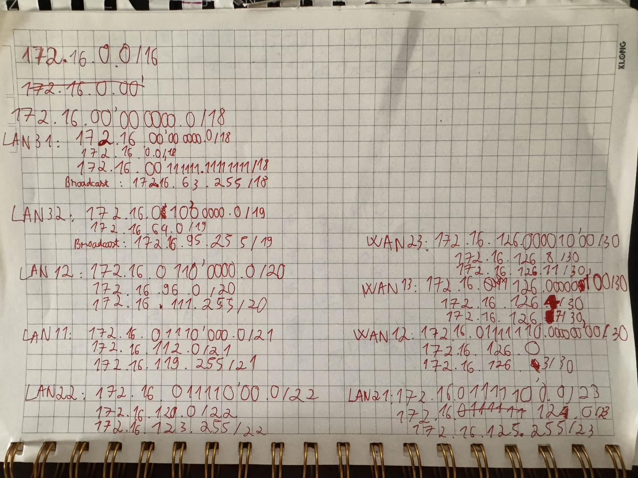

LAN11: Requires 1000 hosts → Needs a /22 subnet (1022 hosts)

LAN12: Requires 2000 hosts → Needs a /21 subnet (2046 hosts)

LAN21: Requires 200 hosts → Needs a /24 subnet (254 hosts)

LAN22: Requires 500 hosts → Needs a /23 subnet (510 hosts)

LAN31: Requires 5000 hosts → Needs a /19 subnet (8190 hosts)

LAN32: Requires 2000 hosts → Needs a /21 subnet (2046 hosts)

WAN12, WAN13, WAN23: Each requires 2 hosts → Needs a /30 subnet (2 hosts)

Subnetting Steps:

Allocate the largest subnets first to avoid fragmentation:

LAN31 (5000 hosts): 172.16.0.0/19 (172.16.0.0 - 172.16.31.255)

LAN32 (2000 hosts): 172.16.64.0/21 (172.16.64.0 - 172.16.71.255)

LAN12 (2000 hosts): 172.16.96.0/21 (172.16.96.0 - 172.16.103.255)

LAN11 (1000 hosts): 172.16.112.0/22 (172.16.112.0 - 172.16.115.255)

LAN22 (500 hosts): 172.16.120.0/23 (172.16.120.0 - 172.16.121.255)

LAN21 (200 hosts): 172.16.124.0/24 (172.16.124.0 - 172.16.124.255)

WAN12 (2 hosts): 172.16.126.0/30 (172.16.126.0 - 172.16.126.3)

WAN13 (2 hosts): 172.16.126.4/30 (172.16.126.4 - 172.16.126.7)

WAN23 (2 hosts): 172.16.126.8/30 (172.16.126.8 - 172.16.126.11)

# REQUIREMENTS

You are expected to complete all tasks in section B (Lab tasks). Advanced tasks are optional, and you could get bonus points for completing those tasks.

Your submission must meet the following requirements:

* You need to submit a **detailed lab report in .docx** *(Word Document)* format,

**using the report template** provided on the UIT Courses website.

* A report written in English is required.
* When it comes to **programming tasks** *(require you to write an application or script),* please attach all source-code and executable files (if any) in your submission. Please also list the important code snippets followed by explanations and screenshots when running your application in your report. Simply attaching code without any explanation will not receive points.
* Submit work you are proud of – don’t be sloppy and lazy!

**8**

Your submissions must be your own. You are free to discuss with other classmates to find the solution. However, copying reports is prohibited, even if only a part of your report. Both reports of the owner and the copier will be rejected. Please remember to cite any source of the material (website, book,…) that influences your solution.

**Notice:** Combine your lab report and all related files into a single **ZIP file (.zip)**, name it as follow:

***StudentID _ReportLabX.zip***